Title: | Intermediate Git Version Control
Updated: | April 3, 2025 | Due Date: | Midnight before the next class meeting.
Purpose: | The purpose of this lab is to provide hands-on experience with Git version control, specifically focusing on creating and managing branches, pushing and pulling code between different machines, and resolving merge conflicts, to develop skills essential for effective collaboration in software development.  This addresses competency 1 – initialize and use a version control system.
Knowledge: | After completing this lab, you will understand how to use Git to manage branches, share code between machines, and resolve merge conflicts in collaborative development environments.
Task/Activity: | A. Creating and Managing Branches  B. Pushing and Pulling Code Between Machines  C. Merging and Resolving Merge Conflicts  D. Reflection
Criteria for Success: | Success in this lab is marked by accurate task completion, effective analysis, documentation, and clear communication of findings. A crucial aspect involves reflecting on the purpose of the lab, linking procedures to broader concepts, and recognizing the lab's significance within the course.  Overall, success is not only measured by technical proficiency but also by critical thinking, effective communication, and a reflective summary that captures the challenges faced and insights gained throughout the lab experience.
- Creating and Managing Branches
In Git, branching allows you to work on separate features, bugs, or other tasks in isolation from the main codebase. This makes it easier to integrate changes later without disrupting ongoing development. To create a new branch, we use the git branch command, and to switch between branches, we use git checkout (or the newer git switch command).
A branch is essentially a pointer to a specific commit, allowing you to have a divergent history from the main branch (often called main or master). You can create a branch for a new feature or bug fix, work on it independently, and later merge it back into the main branch once complete.
Here are the steps to work through this process.
- Ensure you are in a Git repository by initializing one and completing at least one commit or navigating to an existing repo. For this lab, we will create a new repo to work with. Start in the devops folder you created in lab 1 and run the following:
# mkdir lab2
# cd lab2
# git init
# touch README.md ßThis creates an empty file without having to open it
# git add .
# git commit -m “Initial Commit”
- Create a new branch:
# git branch feature-branch
This creates a new branch called feature-branch. However, you're still on the main branch, as creating a branch doesn't switch you to it.
- Switch to the newly created branch:
# git checkout feature-branch
or
# git switch feature-branch
Now, you are on the feature-branch. You can verify this by running:
# git status
On branch feature-branch
nothing to commit, working tree clean
It should indicate that you are now on feature-branch.
- Make some changes to a file, for example, update README.md in VS Code, save the changes, and commit:
# code -r README.md
# git add README.md
# git commit -m "Updated README on feature-branch"
To return to the main branch, use:
# git checkout master
Now, any work done on the feature-branch remains isolated from the main branch until merged. In fact, if you have README.md open in VS Code, the content that you typed should have disappeared!
- Now you know the steps, practice with the following, writing the commands you used for each:
- Create a new branch called experiment-branch.
Paste screenshot 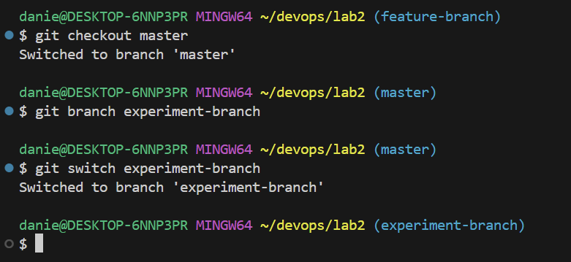
- Add a file named experiment.txt with some content, and commit it.
Paste screenshot 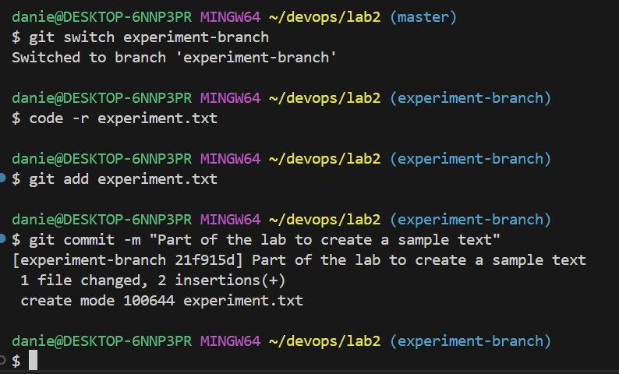
- Switch back to master, and verify that the file experiment.txt is not present (ls) (as it was committed only to experiment-branch).
Paste screenshot 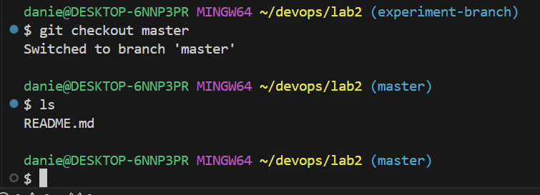
- Pushing and Pulling Code Between Machines
When working in a team or across multiple machines, you need to share your changes with others. This is done by pushing your commits to a remote repository (e.g., GitHub) and pulling updates from others. The command git push uploads your changes, while git pull fetches and merges changes from the remote repository.
Lets use the my-first-repo you have on Github.
- Create a folder in your devops folder called lab2-2 and navigate into it. Then create a repository in it.
# cd ..
# mkdir lab2-2
# cd lab2-2
# git init
- Link your local repository to a remote:
# git remote add origin https://github.com/username/my-first-repo.git
Note: Be sure to update the path above to your repo.
Linking your local repository to your remote repository tells git where to pull (download) or push (upload) changes to.
- Pull your existing files from that repo:
# git pull origin main
- Edit README.md and add or change some text. Stage the file and commit it.
- Create a new branch called feature-branch. Change to that branch and edit the README.md file. Save the changes, stage the file, and commit to the feature-branch.
- Push your changes on the current branch to the remote repository:
# git push origin feature-branch
Note: You may be prompted to login to GitHub because of the different way we are doing this. If so, choose the connect through the browser option and authenticate with GitHub.
This command pushes the feature-branch to the remote repository. It will be available for others to pull and work on.
Pick a partner that you are going to do this next step with. Get their GitHub username for the next step.
- Go to GitHub in your browser and navigate to your my-first-repo repository.
- Select the Settings tab along the top of the repository.
- Select Collaborators on the left menu.
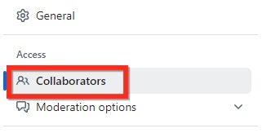
- Select “Add people.”
- Enter your partner’s GitHub username, or email address to add them to your repository. This will allow them to make contributions to your repository. They should check their email to accept the invitation to collaborate.
Paste screenshot showing user added on GitHub 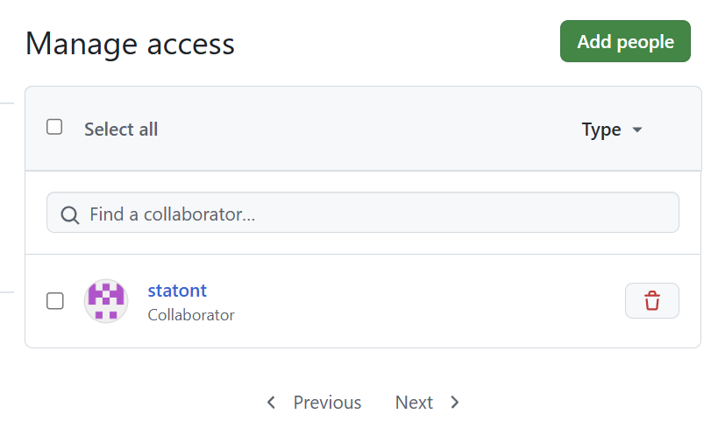
- Once your partner has accepted, have your partner clone your repository in a new folder on their machine (they should create a new folder in the devops folder and initialize it with git init):
# git clone https://github.com/username/repo-name.git
This copies your repository to their machine.
Paste screenshot 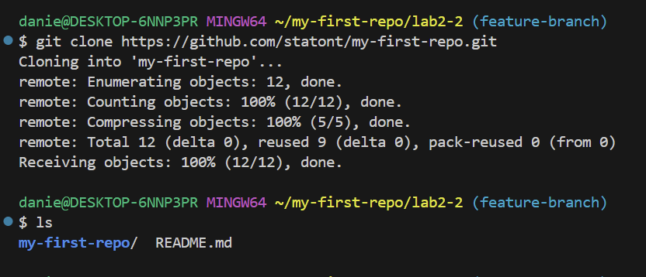

Your partner should perform these steps to add you to their repository, and clone their repository to your computer.
- Navigate into the folder that was cloned and add your name to the README.md file. Save the file.
- After making changes on a new machine and committing them, push the changes to the remote using:
# git push
Screenshot of these steps 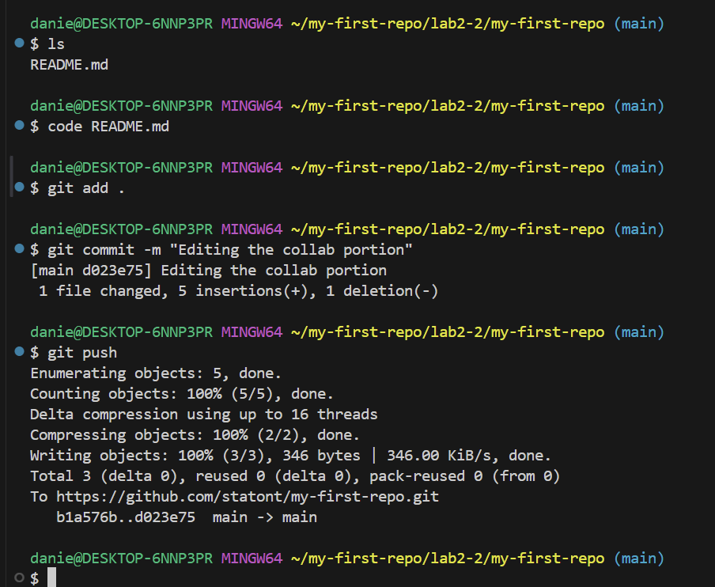
- On your partner’s computer, have them pull down the changes you made to their local copy.
# git pull ß Make sure to run this in your partner’s repo folder, not your repo folder
- Navigate back to the folder with your partner’s repo. Create a branch with your first name as the branch name and change to it. For example:
# git branch tages
# git switch tages
- Create a file with your name as a text file:
# touch tages.txt
- Open the file and add the text “Tage was here” changing Tage to your first name. Save, stage, and commit this change.
- Push the new branch to GitHub:
# git push origin tages ß Be sure to change tages to your branch name
- On GitHub, you should see a branch message has appeared on your repo: 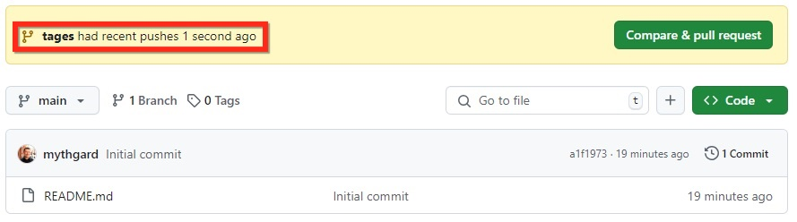
- Click “Compare & pull request” to see the branch and changes. Scroll to the bottom to see the file that was updated. The green shows lines that were added. Any red lines were lines that were deleted or modified.
- To merge this brach into the main branch, you can create what is called a pull request. This will allow you to collaborate with others on this branch, eventually leading to a merge of the branch into the main branch. Click on “Create pull request.” 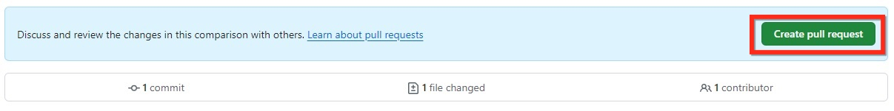
- Here, you can add comments and go back and fourth with a collaborator to make requested changes. When you are satisfied with the changes, click on the “Merge pull request” button, then “Confirm merge” to merge the branch into main.
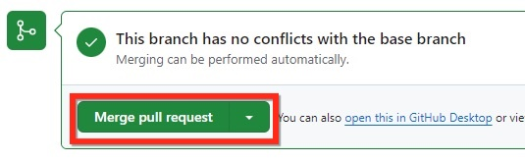
After the merge is complete, select the “Delete branch” button to remove the branch and keep your repository clean.
- Navigate to the code tab of your repository and view the updated file.
Paste screenshot showing the change on GitHub 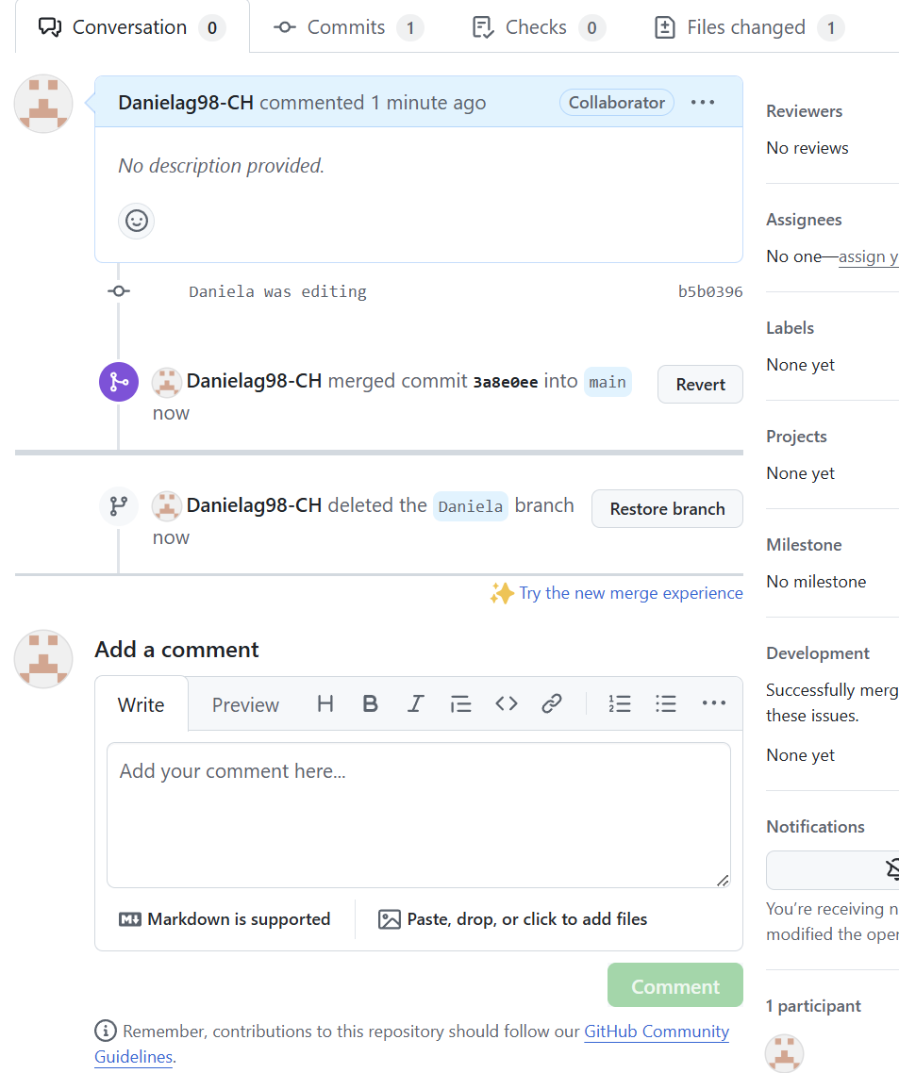
- Merging and Resolving Merge Conflicts
Merge conflicts occur when two branches have made conflicting changes to the same part of a file, and Git cannot automatically resolve them. A conflict must be manually resolved by reviewing the changes. The git merge command is used to combine branches, and when conflicts arise, Git marks the conflicting sections in the files.
Navigate to the lab2-2 folder in your devops folder you created earlier.
We will create a merge conflict:
- Switch to the main branch:
# git checkout master
- Make a small edit to README.md on the main branch and commit:
# git add README.md
# git commit -m "Updated README on main"
Screenshot of commands run 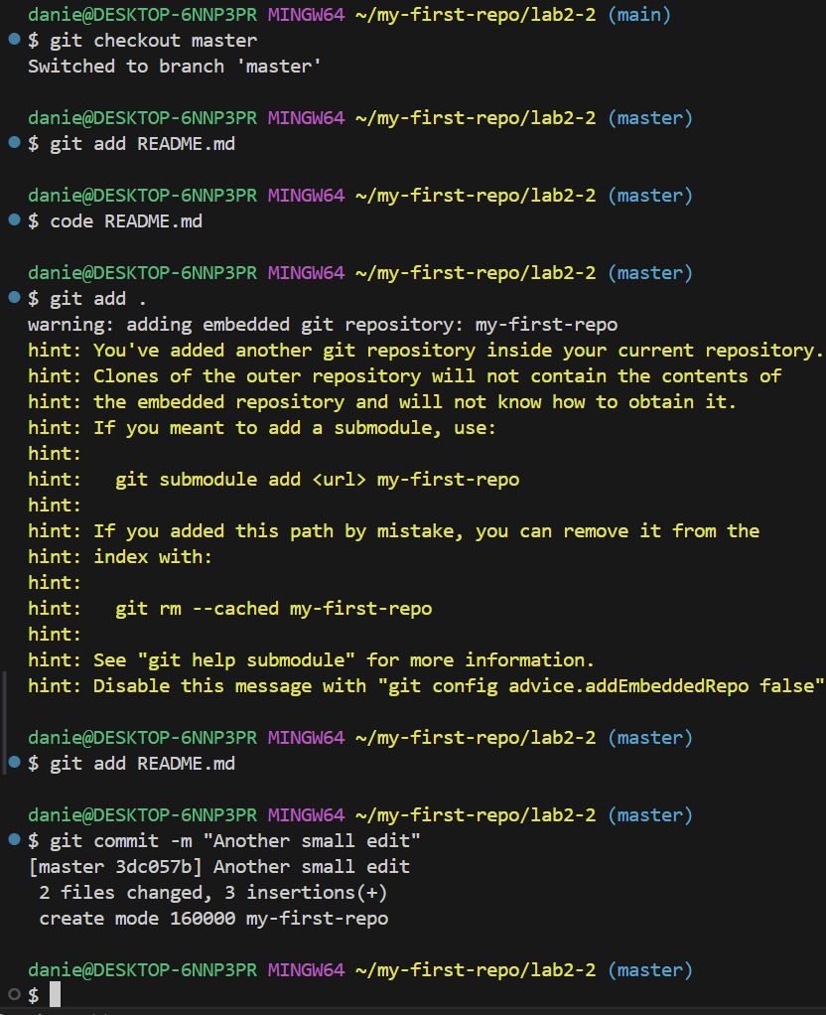
- Switch back to the feature-branch:
# git checkout feature-branch
- Make another change to the same section of README.md and commit it:
# git add README.md
# git commit -m "Updated README on feature-branch"
- Now, try to merge feature-branch into main:
# git checkout master
# git merge feature-branch
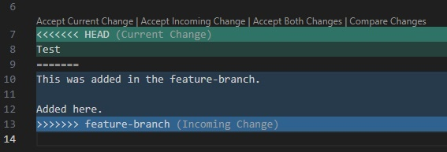
Git will alert you of a merge conflict. Open the conflicting file (README.md), and you will see conflict markers like:
<<<<<<< HEAD
Changes from master branch
=======
Changes from feature-branch
>>>>>>> feature-branch
- Edit the file to manually resolve the conflict by keeping the correct content or combining both.
- After resolving the conflict, mark the file as resolved:
# git add README.md
- Finally, complete the merge:
# git commit -m "Resolved merge conflict between main and feature-branch"
Paste screenshot of commands here 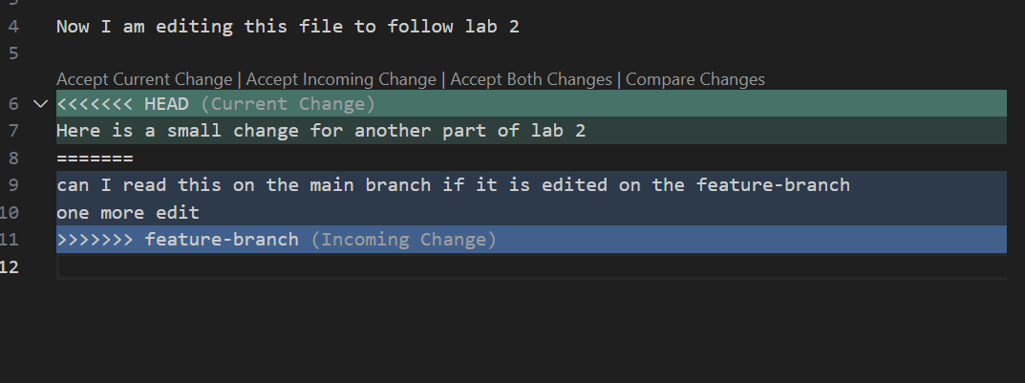
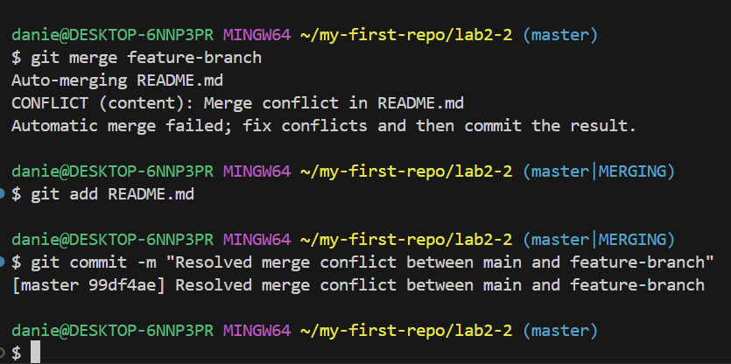
- Reflection
This lab has introduced you to the key concepts of Git branching, pushing and pulling code, and resolving merge conflicts. By mastering these, you can work efficiently in a team, manage parallel workstreams, and tackle the challenges of working on shared codebases across different machines. Keep practicing these skills to improve your confidence in working with Git in real-world projects.
I found that I struggled the most with creating and finding file paths that I created. I am not sure how it happened, and I am hoping to resolve this as this class progresses, but in creating my folders I made a mistake and somehow, they were split. For example, I have “my-first-repo" as its own folder and not inside a “devops” folder like previously instructed in prior labs, and I do not know where I went wrong in the coding. After I resolved/found where is needed to work, following the instructions was fun. I did have a few errors but thankfully they were explained in a way that was easy for me to see my mistakes.

